Conduct for Mounted Followers

- Always remember that we ride across other people’s private land. This is a great privilege to be treated with the utmost respect. Remember that without the generosity and goodwill of our farmers and landowners the sport we love would be denied to us. Anything which puts that goodwill at risk is unacceptable.
- Always be friendly and polite to everyone at all times. Thank motorists, cyclists, pedestrians and members of the public with a wave and a smile. Remember, the person standing holding a gate open for you may well be the owner on whose land you happen to be riding.
- At the Meet you should be correctly dressed with clean tack and a well turned out horse. This shows respect to our hosts.
- Arrive at the meet in good time. Always say ‘Good Morning’ to the Master, Duty Secretary and Hunt Staff.
- Never park your vehicle in such a way as to cause inconvenience to others.
- Never ride across the middle of seeded fields. Be mindful of stock in a field, walk around the side rather than cantering through the middle of livestock.
- Make sure that the person after you understands that a gate needs to be closed by clearly saying ‘gate please’ or if out of earshot, by raising your arm. DO NOT MOVE AWAY until they have clearly acknowledged that the gate is to be shut.
- Don’t leave a mounted follower alone when they are closing a gate, offer assistance and stay until it has been shut properly.
- Always wait for the horse immediately behind when crossing a wooden bridge. Do not move off until they have crossed safely.
- If others are jumping a fence next to a gate that you intend to use, wait until they have finished before opening the gate.
- Move quickly to the side if the Huntsman, Whipper-In or Master comes past you. Let those ahead know the above need to pass.
- Always turn your horses’ quarters away from hounds when they come close to you. Do not give your horse any opportunity to kick a hound.
- Stay behind the Field Master at all times and follow his or her instructions.
- Do not talk loudly; others may be trying to listen to hounds. Keep your mobile telephone on ‘silent’.
- Make sure your brakes work well. The Hunting Field is not a race circuit and the horse in front is not there for use as your personal rail track buffer!
- When jumping, keep a straight line and give yourself enough room to react if the horse in front refuses. Wait your turn and do not push to the front of the queue. If your horse stops get out of the way as quickly as possible to avoid impeding others before trying again.
- Warn others of hazards such as holes or wire.
- Always walk through a farmyard, especially if there are livestock in buildings, or across smooth concrete.
- Keep a safe distance from the horse in front, don’t trust it not to kick.
- Red tape on a tail means the horse has been known to kick. Green tape means the horse is young or inexperienced and therefore may kick out if frightened. Give both plenty of room.
- Putting red or green tape on your horses’ tail does not absolve you in any way of responsibility for your horse. If you think your horse may kick keep it away from others and to the rear of the field. Should you find yourself surrounded by others then one hand held behind your back will warn them of the need for extra space.
- If someone has fallen off or is in trouble offer to help – it may be you next time!
- In the event of provocation from ‘Antis’ think twice before reacting. Yet another clip on Youtube showing a Hunt follower losing his / her temper, will do our sport no favours.
- When going home it is polite to say ‘Goodnight’ to the Master. Before leaving please check with the Master or Duty Secretary to confirm that your intended route home does not cross land not accessible to the Hunt on that particular day.

Children

The Masters are delighted to welcome children hunting with the OBH, but would be grateful if their parents / guardians could take note of the following advice:

- Children out hunting should carry a mobile telephone with their parents / guardians number easily locatable.
- Children out hunting should wear headgear and body protectors which conform to current EU Safety Standards.

Supervision of Children out Hunting:

- Children 5 years and under should be on a lead rein.
- Parents / guardians should arrange for children between the ages of 6 and 12 to have adult supervision out hunting unless they hold a Pony Club C Test of have the requisite experience to hunt unaccompanied.
- Children between the ages of 13 and 17 many hunt unsupervised provided they hold a Pony Club C test of have the requisite experience to hunt unaccompanied.
- It is not the responsibility of the Hunt, nor of any of its officers, to supervise unaccompanied children, unless they have agreed to do so in advance.
- If your child wishes to come out hunting, he / she must have Third Party Liability insurance cover, at the least to the extent afforded by membership of the Countryside Alliance.

Neither the Company nor individual members can accept any liability or responsibility for any accident or incident to any supporter or follower of the Hunt.

The Countryside Alliance

The Policy of the Company is that all mounted follows belonging to the Old Berkshire Hunt Ltd should be a member of the Countryside Alliance. If you are not a member please contact a Hunt Secretary. Your membership of the Countryside Alliance provides the necessary insurance.

Liability

Everyone coming hunting, whether mounted or on foot, does so entirely at their own risk. The Company does not accept liability for any injury, loss or damage, to person or property sustained, how so ever caused, at any time in the course of a days hunting.

The Company requests that all follows of the Hunt, either mounted or on foot, ensure that they are fully insured for Third Party Liability. All Countryside Alliance Members are suitably covered.

Information for Newcomers & Subscribers and Hunting Etiquette

Introduction

The Old Berkshire Hunt is a friendly Hunt and likes to welcome Newcomers as well as our regular Subscribers to the sport. Most of the following advice is second nature to many Subscribers as they have been with us for so long. However, without causing offence to the more experienced amongst our Field, hopefully these tips will prove helpful to all. We accept that novices can find their first hunting venture a bit daunting and also Subscribers, perhaps coming back after a gap, might find the information useful.

Hunting should not be regarded as old fashioned as, in fact, most of the traditions, etiquette and behaviour associated with hunting are practical and exist for very good reason, such as, to show a mark of respect to the landowners whose land the Hunt crosses and to show appreciation for the work that Hunt officials have put in to planning for the day’s sport.

When planning your first day, please get in touch with the Hunt Secretary to find out which meets are suitable for Newcomers. Meets such as Christmas Eve, Boxing Day or New Year’s Day may not be suitable due to the mix of the general public and horses.

If you prefer to go with the non-jumping field, please find out on arrival at the Meet who will be taking the non-jumpers and make yourself known to them.

One of the greatest joys of foxhunting is the unique chance it affords its followers to ride over private land and view the countryside. Our Hunt is greatly indebted to the many landowners and farmers who allow us to access their land, and is mindful that this privilege is not abused. The Hunt is judged by the conduct of its followers. The lack of consideration and common sense of just one person can lose Country to the Hunt for all time.

Remember—We all had a first time and if in doubt ask.

Contact Details

Hon Secretary: Mr Richard Holt

Tel: 07818 598059

Email: r-holt@hotmail.co.uk

Hon Secretary: Ms C Brown

Tel: 01993 867530

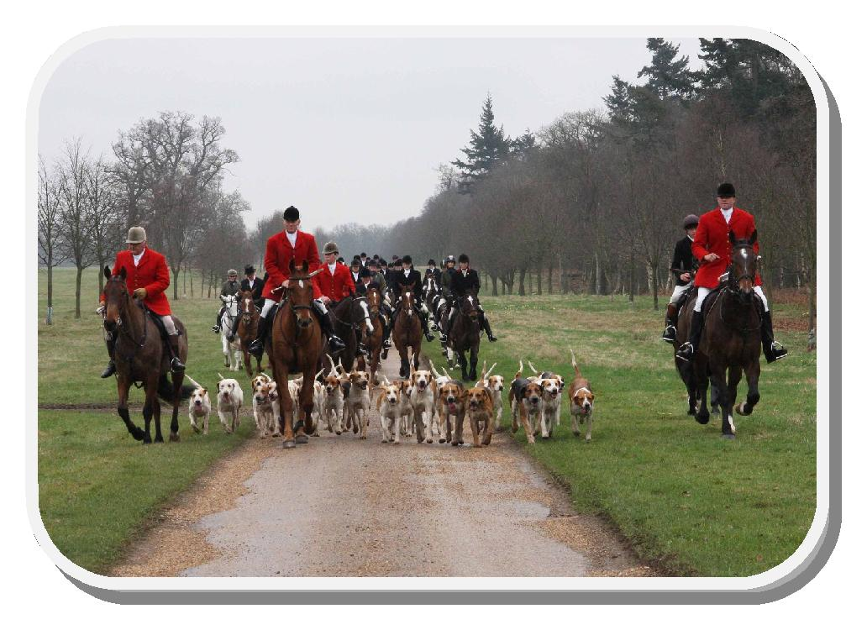

Point-to-Point Qualification

Anyone wishing to qualify their horse to race in Point-to-Points is required to register a Hunter’s Certificate stating that the horse has been regularly and fairly hunted. Mr Michael Bowlby MFH, is responsible for issuing these certificates. To enable him to keep a record of the horses being qualified, they must be presented to him at the Meet each time they are brought out (in his absence to one of the Joint Masters) together with a card stating the horse’s name and colour to avoid any confusion. It should be noted that the qualification of Point-to-Point horses can be started from the first day of Autumn Hunting season.

Parking at Meets

- Vehicles must be parked at the Meet unless you are otherwise notified.

- Please take some time to work out where best to park your vehicle so as to allow as many other people as possible also to park in comfort.

- The first people to arrive should park at the edge of an area and then subsequent arrivals line up alongside them so that the maximum use is made of the space.

- Drivers of 4x4s should remember that they can go in places where lorries cannot go and thus consider going in those spaces to leave the harder standing available for the heavy vehicles (but always remembering the weather conditions and making sure not to cause unnecessary mess).

- Do not park in gateways or in front of farm buildings or machinery which may require access during the day.

- Do not park on blind corners or bends where you may cause a nuisance to the general public.

- Make sure that your vehicle is locked and ramps on all horseboxes and trailers are closed.

- Ensure that the registration number of your trailer matches that of the vehicle towing it.

The Hunting Year

Officially our year begins on 1st May, which is the date upon which new staff or Masters begin their duties, but it is easier to follow the pattern of the year if we begin when hunting begins which, for us, is when harvest allows (normally the beginning of September).

Autumn Hunting

In this very early part of the season Meets are held early in the morning before the temperature rises and evaporates the scent. Meets are usually held three or four times a week, most are shortly after sun-rise and some are Saturday afternoons they are part of the process of preparing horses, hounds and the Country for the coming season. The Dress code for Autumn Hunting is called ‘Ratcatcher’ (see Terminology and Hunting Phrases for a brief description).

The Main Season

The ‘formal season’ starts on the first Saturday in November with ‘The Opening Meet’. This is one of the highlights of the year when supporters gather to enjoy the hospitality of our host. It’s a time to catch up with old friends and make new ones.

Who is Who

The Masters

The Masters are in overall command of the hunting activities. They decide when and where hounds will meet, what coverts are to be drawn and when hounds will go home. They are responsible for hounds showing the best possible sport under existing conditions. They are responsible for hounds and the staff and ensure the riders only go where they are permitted, neither causing damage nor annoying the landowners who make the sport possible.

The Huntsman

The Huntsman controls hounds, indicating to them by his horn or voice when he wishes them to follow a trail. He attempts to be sure that hounds work together as a pack by encouraging the tail hounds and steadying the lead hounds. In the case of a check he must be prepared to assist hounds to recover the line by use of a cast if necessary. His technical decisions must be quickly made and Staff and Field must abide by them.

The Whippers-in

The Whippers-in assist the Huntsman in controlling hounds by turning them back to the Huntsman or by encouraging them forward to him as necessary. Whippers-in are also used by the Huntsman to retrieve hounds should they engage a hare or deer. No-one except the Huntsman gives orders to Whippers-in. No-one, except by request of the Huntsman or Master, should accompany them or attempt to assist them.

The Field

The Field consists of the mounted followers and is controlled by the Field Master who rides at the head of it. The Field Master is responsible for leading and controlling the Field across the Country in pursuit of hounds. Whilst seeing that the Field does not interfere with hounds in their work, he is also responsible for seeing that the Field avoids damage to the landowners’ property. The Field should follow behind the Field Master, never overtaking, and follow his/her instructions.

The Secretary

The Secretary deals with the Hunt’s administration. The Field Secretary collects the Field Money or Cap (payment for the day) at the Meet and is happy to help you in any way.

The Terrier Men

The Terrier Men are normally seen out hunting on a quad bike and are involved in fox control.

Hunting Etiquette

Before the Meet

Check the Meet Card for where and when the Hunt is meeting. If you are not a Subscriber please ring the Secretary and ask if you may join the Hunt for the day. Newcomers should check that the Meet is suitable for them and she will advise you where to park.

Arrival at the Meet

You should look smart and wear the correct clothing which comprises:

Autumn Hunting

- Beige or Buff breeches or jodhpurs.

- Tweed jacket (Ratcatcher)

- Coloured stock or collar and tie.

The Main Season

- Beige or Buff breeches or jodhpurs.

- Black Hunt coats (ladies may also wear blue)

- White or cream stock.

- Black (or ladies—blue) Hunt hats or skull caps with correctly fitting covers. Traditional top hats or bowlers may also be worn.

- Long hair should be kept tidy with a hairnet.

- Most children wear ratcatcher, collar and tie throughout the season.

- Newcomers and occasional hunters may wear ratcatcher during the season if they do not own a hunt coat.

- If it is raining heavily permission to wear waterproofs should be sought from the Master of the day.
- Ensure your horse and their tack is clean and well turned out.

- Numnahs / saddle cloths should be plain and discrete.

- Manes should be plaited for lawn or ‘show’ Meets such as, Opening Meet, Boxing Day, etc.

- Unplaited manes should be pulled and tidy, the exception being native breeds.

Aim to arrive at least fifteen minutes before the time of the Meet and be mounted at the Meet by the time stated on the Meet Card. Seek out the person responsible for collecting caps, usually the Field Secretary, who will also be able to help with any queries you may have. Please do not leave it to them to seek you out.

Hunting is a sport to enjoy. The more people you talk to at the Meet, the happier the atmosphere that is created and the quicker you will make friends.

During the Hunt

If your horse is a novice a Green ribbon should be worn at the top of its tail.

Never ride a kicking horse in a crowd. If your horse is a kicker, or very excitable, try to ensure that you maintain a safe distance from other horses. Always wear a red warning ribbon at the top of the horse’s tail. Your horse should be suitably admonished should it kick out.

Make sure to face your horse or pony to the hounds should you be in close proximity to them. Do not allow your horse to tread upon or kick a hound. A horse will by instinct kick out at something that comes up unexpectedly from behind.

Ensure you stay behind the Field Master and do not get in the way of the Huntsman or Whippers-in.

Pass on any messages when they come loud and clear—e.g. ‘keep in please’ or ‘hole on the left’.

Ride in single file along headlands of fields and please keep off seeded or growing crops and mown grass.

Please shut gates! Gates left open can cause much unnecessary trouble and dangers to our hosts and their stock. Please thank any person who opens the gate and do not ride off and leave a mounted follower to shut a gate on their own.

When jumping, wait for the rider in front to get clear of the fence. Once you have picked a spot on the fence or ditch, try to stick to it. If your horse refuses then let the others go first before trying again.

The Field Master will be trying to listen and to maintain ‘contact’ with the Huntsman and the hounds so please be conscious of this when you are chatting to friends.

If a rider falls—first check the rider and then catch their horse, if you can, and return it to the rider.

Show consideration to our foot followers and do not gallop so close that you cover them in mud.

If you should damage a fence, gate or any other of the landowners property, ensure you leave it stock proof and report it to the Master as soon as practicable. If you forget to mention it or can’t find someone, it could result in livestock getting out on to the road, so a phone-call to one of the Hunt Officials to inform them will be gratefully received.

Pay special attention to courtesy and consideration of road users. Every motorist whom we impede and delay is a potential enemy of our Hunt and hunting in general. Ride in single file on all roads and please acknowledge all motorists, even inconsiderate ones. They may be shamed into better manners next time.

At the end of the day (or when you decide to finish) be sure to thank the Master and say ‘Goodnight’.

Following by Car

Following hounds by car is an art, calling for extreme patience, with almost a sixth sense if you are to be in the right spot at the right time. Here is some advice to get you off to a good start:

- The most important thing to remember when following by car is to be discrete and hear without being heard.

- Switch off your engine as soon as you stop. Foot followers depend so much on hearing, that a running car can be a great nuisance to other followers. Exhaust fumes will also mask scent.

- Park on one side of the road only.

- Assist Hunt Officials by opening and closing gates for them.

- Do not obstruct mounted Hunt Staff and followers.

- Avoid parking on mown grass verges and if you find you have by mistake, be extra careful not to wheel-spin when you move off.

- Avoid causing an obstruction to other road users, parking in gateways, driveways or junctions.

- Do not leave public highways and drive on private land or tracks unless express permission is given.

Terminology and Hunting Phrases

Autumn Hunting The early part of hunting from August / September until the Opening Meet

Cap A daily charge for Non-Subscribers

‘Car Please’ Is shouted to tell the Field to keep to the left to let cars through on the road

Cast When hounds are looking for the line. The Huntsman may cast hounds towards where he thinks hounds will pick it up

Check When hounds lose the line

Couples Hounds are counted in couples, ie. One couple = 2, a couple and a half = 3, two couples = 4, etc. When young hounds are in training they are ‘coupled’ up with an experienced hound using two collars linked on a chain

Feather Hounds are said to feather or be feathering when they have the line but are unable to speak to it

Field The mounted followers

Field Master The person in charge of leading and controlling the Field

‘Gate Please’ Shouted backwards on going through a gate which should be closed

‘Good Morning’ The appropriate greeting at the Meet

‘Good Night’ The appropriate salutation for the end of the day even if it was an Autumn hunting morning which ended before midday

Green ribbon Worn on the tail of a young horse - give it some space

Red ribbon Worn on the tail of a known kicker. These horses should be kept at the back of the Field until they become educated and no longer need to wear a ribbon

Hat ribbons Hunt caps and most riding hats have ribbons on the back, the ends of which hang down when they are bought. Only Masters, Hunt Officials and Hunt Staff should have their ribbon-ends hanging down, so members of the Field should sew their ribbons up or remove them. This is to help members of the Field tell if they are following a Master, Hunt Official or Hunt Staff

Hunt buttons When you first start hunting the buttons on your hunting jacket should be plain. Subscribers who, over a period of time, have gained knowledge and been helpful to the Hunt may be awarded, by the Masters, with the Hunt’s buttons to go on their hunting coat

Hand behind back Means this horse might kick if you crowd it

Hand in air Signal that the Field is slowing down and coming to a halt

Hand in air Signal to people coming towards a gate but, out of hearing, that the gate

by gateway should be shut. The response to which should be to hold your hand in the air to show you have got the message and will shut the gate

Whip in the air (usually by Field Master) - This means stand still where you are, not wait until you get level with the Field Master and then stop

Harrier A hound that was originally bred for hunting hares

Heel Hounds are said to be hunting heel when they hunt the reverse

‘Hold Hard’ Shouted by the Field Master to stop the Field

Hound All scent hunting dogs are referred to as hounds

Hunt A hunting day usually consists of several hunts, each hunt varying in length, sometimes incorrectly referred to as ‘runs’ or ‘lines’

Huntsman The person who hunts hounds. There is only one Huntsman on the hunting field and he has right of way at all times

Hunt Button Subscribers who, over a period of time, have gained knowledge and been helpful to the Hunt may be awarded the Hunt’s buttons

Hunt Staff The people responsible for working hounds, ie. Huntsman and Whippers-in. They may be Masters, amateurs or professionals

‘Keep in Please’ A signal given to members of the Field when riders must keep in to the verge or off the crop

‘Kick on’ You may get this response when you make way for someone at a gate or jump. It means you don’t have to wait for him/her and should carry on. Or it may be just general encouragement

Line The scent left by the trail

‘Loose Horse’ Shouted when someone has fallen off and the horse is running away

Master Maybe a Joint Master. These are the people responsible for the running of the Hunt and should be greeted as ‘Master’ and referred to as such throughout the day. They should have right of way at all times second only to the Hunt Staff

‘Master/ This means give way to these people as they have a job to do. If it is heard

Huntsman/ on a road or a track everyone should get to one side, not line both sides, to

Whip/Hound reduce the chances of them being kicked

Please’

‘Master/Huntsman/ This means the Master/Whip/Hound should be let through on the side

Whip/Hound on shouted. The side corresponding to the direction of travel of the majority

right/left’ of the Field

Members Are Subscribers or farmers who have been invited by the Masters to wear the Hunt’s buttons

Mixed Pack A pack consisting of dogs and bitches

Opening Meet The start of formal hunting

Puppy A hound which is new to hunting that season. It will appear fully grown

Ratcatcher Term used to describe the official dress for mounted followers during Autumn Hunting and consists of a Tweed jacket as opposed to a black jacket

Riot or When hounds hunt something other than that which they are supposed to be

Rioting hunting, they are rioting

Speak or Hounds do not bark, they speak or are speaking when they are ‘on the line’

Speaking (hunting a scent)

Stern A hound’s tail

Walk Hounds at walk, often known as Puppy Walking is where whelps are sent to private homes, in minimums of two’s, from the age of eight weeks until they get too big and boisterous for the walkers, at which point they return to kennels to learn how to fit in to the pack

‘Ware’ Ware is often pronounced ‘War’ and means beware

Hole / Wire Therefore if you hear ‘War Hole’ it actually means mind out there is a hole in the ground coming up! Similarly any other hazards

Whelp A new born hound is a whelp and remains so until it comes back from walk

Whipper-in The person who helps the Huntsman control hounds. This person has right of way at all times and will only give way to the Huntsman

Whip A Hunting Whip with Thong and Lash is correct and also aids with opening and closing gates.

Remember that a day’s hunting is a day for enjoyment and the company of good friends.

GOOD HUNTING!

For further information regarding hunting etiquette please refer to the Baily’s Hunting Directory

