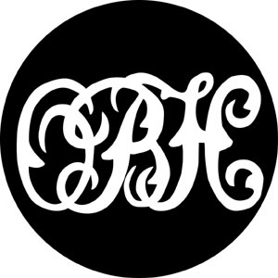

FUN RIDE
SUNDAY 23rd APRIL 2017

Start and finish at Lockinge Point to Point Course OX12 8PA

2 miles South East of Wantage on B4494 (8m North West of Exit 13, M4)
A FABULOUS 10 MILE (APPROX) SCENIC RIDE ALONG THE DOWNS AND ACROSS LOCKINGE ESTATE,EITHER SIDE OF THE RIDGEWAY, INCORPORATING PRIVATE LAND,WOODLAND,BRIDLEWAYS AND CULMINATING WITH THE LOCKINGE POINT TO POINT COURSE.

APPROX 40 OPTIONAL FENCES

Refreshments available at the start and finish as well as at The Harrow,East Ilsley
10.00 am to 4.00pm (Last start time 2pm)

Enter on line with www.Horse-Events.co.uk

Secretary Caroline Keen 07768 038606

